**BANK LOAN REPORT QUERY DOCUMENT**

1. **BANK LOAN REPORT | SUMMARY**

**KPI’s:**

**Total Loan Applications**

SELECT COUNT(id) AS Total_Applications FROM bank_loan_data



**MTD Loan Applications**

SELECT count(id) FROM MTD_bank_loan_data

WHERE MONTH(issue_date) = (SELECT MAX(MONTH(issue_date)) FROM bank_loan_data)

AND YEAR(issue_date) = (SELECT MAX(YEAR(issue_date)) FROM bank_loan_data)

OR

SELECT COUNT(id) AS MTD_Total_Applications FROM bank_loan_data

WHERE MONTH(issue_date) = 12 AND YEAR(issue_date) = 2021



**PMTD Loan Applications**

SELECT count(id) AS PMTD_Total_Applications FROM bank_loan_data

WHERE MONTH(issue_date) = (SELECT MAX(MONTH(issue_date)-1) FROM bank_loan_data)

AND YEAR(issue_date) = (SELECT MAX(YEAR(issue_date)) FROM bank_loan_data)

OR

SELECT COUNT(id) AS PMTD_Total_Applications FROM bank_loan_data

WHERE MONTH(issue_date) = 11 AND YEAR(issue_date) = 2021



**Total Funded Amount**

SELECT SUM(loan_amount) AS Total_Funded_Amount FROM bank_loan_data



**MTD Total Funded Amount**

SELECT SUM(loan_amount) AS MTD_Total_Funded_Amount FROM bank_loan_data

WHERE MONTH(issue_date) = (SELECT MAX(MONTH(issue_date)) FROM bank_loan_data)

AND YEAR(issue_date) = (SELECT MAX(YEAR(issue_date)) FROM bank_loan_data)

**OR**

SELECT SUM(loan_amount) AS MTD_Total_Funded_Amount FROM bank_loan_data

WHERE MONTH(issue_date) = 12 AND YEAR(issue_date) = 2021



**PMTD Total Funded Amount**

SELECT SUM(loan_amount) AS PMTD_Total_Funded_Amount FROM bank_loan_data

WHERE MONTH(issue_date) = (SELECT MAX(MONTH(issue_date)-1) FROM bank_loan_data)

AND YEAR(issue_date) = (SELECT MAX(YEAR(issue_date)) FROM bank_loan_data)

**OR**

SELECT SUM(loan_amount) AS PMTD_Total_Funded_Amount FROM bank_loan_data

WHERE MONTH(issue_date) = 11 AND YEAR(issue_date) = 2021



**Total Amount Received**

SELECT SUM(total_payment) AS Total_Amount_Collected FROM bank_loan_data



**MTD Total Amount Received**

SELECT SUM(total_payment) AS MTD_Total_received_amount FROM bank_loan_data

WHERE MONTH(issue_date) = (SELECT MAX(MONTH(issue_date)) FROM bank_loan_data)

AND YEAR(issue_date) = (SELECT MAX(YEAR(issue_date)) FROM bank_loan_data)

**OR**

SELECT SUM(total_payment) AS Total_Amount_Collected FROM bank_loan_data

WHERE MONTH(issue_date) = 12 AND YEAR(issue_date) = 2021



**PMTD Total Amount Received**

SELECT SUM(total_payment) AS PMTD_Total_received_amount FROM bank_loan_data

WHERE MONTH(issue_date) = (SELECT MAX(MONTH(issue_date)-1) FROM bank_loan_data)

AND YEAR(issue_date) = (SELECT MAX(YEAR(issue_date)) FROM bank_loan_data)

**OR**

SELECT SUM(total_payment) AS Total_Amount_Collected FROM bank_loan_data

WHERE MONTH(issue_date) = 11 AND YEAR(issue_date) = 2021



**Average Interest Rate**

SELECT ROUND(AVG(int_rate),4) *100 AS Avg_Int_Rate FROM bank_loan_data



**MTD Average Interest**

SELECT ROUND(AVG(int_rate),4)*100 AS MTD_Avg_Int_Rate FROM bank_loan_data

WHERE MONTH(issue_date) = (SELECT MAX(MONTH(issue_date)) FROM bank_loan_data)

AND YEAR(issue_date) = (SELECT MAX(YEAR(issue_date)) FROM bank_loan_data)

**OR**

SELECT AVG(int_rate)*100 AS MTD_Avg_Int_Rate FROM bank_loan_data

WHERE MONTH(issue_date) = 12 AND YEAR(issue_date) = 2021



**PMTD Average Interest**

SELECT ROUND(AVG(int_rate),4)*100 AS PMTD_Avg_Int_Rate FROM bank_loan_data

WHERE MONTH(issue_date) = (SELECT MAX(MONTH(issue_date)-1) FROM bank_loan_data)

AND YEAR(issue_date) = (SELECT MAX(YEAR(issue_date)) FROM bank_loan_data)

**OR**

SELECT AVG(int_rate)*100 AS PMTD_Avg_Int_Rate FROM bank_loan_data

WHERE MONTH(issue_date) = 11 AND YEAR(issue_date) = 2021



**Average DTI**

SELECT ROUND(AVG(dti),4) *100 AS Avg_dti FROM bank_loan_data



**MTD Avg DTI**

SELECT ROUND(AVG(dti),4)*100 AS MTD_Avg_dti FROM bank_loan_data

WHERE MONTH(issue_date) = (SELECT MAX(MONTH(issue_date)) FROM bank_loan_data)

AND YEAR(issue_date) = (SELECT MAX(YEAR(issue_date)) FROM bank_loan_data)

**OR**

SELECT AVG(dti)*100 AS MTD_Avg_DTI FROM bank_loan_data

WHERE MONTH(issue_date) = 12 AND YEAR(issue_date) = 2021



**PMTD Avg DTI**

SELECT ROUND(AVG(dti),4)*100 AS PMTD_Avg_dti FROM bank_loan_data

WHERE MONTH(issue_date) = (SELECT MAX(MONTH(issue_date)-1) FROM bank_loan_data)

AND YEAR(issue_date) = (SELECT MAX(YEAR(issue_date)) FROM bank_loan_data)

**OR**

SELECT AVG(dti)*100 AS PMTD_Avg_DTI FROM bank_loan_data

WHERE MONTH(issue_date) = 11 AND YEAR(issue_date) = 2021



**GOOD LOAN ISSUED**

**Good Loan Percentage**

SELECT

(COUNT(CASE WHEN loan_status = 'Fully Paid' OR loan_status = 'Current' THEN id END) * 100.0) /

COUNT(id) AS Good_Loan_Percentage

FROM bank_loan_data



**Good Loan Applications**

SELECT COUNT(id) AS Good_Loan_Applications FROM bank_loan_data

WHERE loan_status = 'Fully Paid' OR loan_status = 'Current'



**Good Loan Funded Amount**

SELECT SUM(loan_amount) AS Good_Loan_Funded_amount FROM bank_loan_data

WHERE loan_status = 'Fully Paid' OR loan_status = 'Current'



**Good Loan Amount Received**

SELECT SUM(total_payment) AS Good_Loan_amount_received FROM bank_loan_data

WHERE loan_status = 'Fully Paid' OR loan_status = 'Current'



**BAD LOAN ISSUED**

**Bad Loan Percentage**

SELECT

(COUNT(CASE WHEN loan_status = 'Charged Off' THEN id END) * 100.0) /

COUNT(id) AS Bad_Loan_Percentage

FROM bank_loan_data



**Bad Loan Applications**

SELECT COUNT(id) AS Bad_Loan_Applications FROM bank_loan_data

WHERE loan_status = 'Charged Off'



**Bad Loan Funded Amount**

SELECT SUM(loan_amount) AS Bad_Loan_Funded_amount FROM bank_loan_data

WHERE loan_status = 'Charged Off'



**Bad Loan Amount Received**

SELECT SUM(total_payment) AS Bad_Loan_amount_received FROM bank_loan_data

WHERE loan_status = 'Charged Off'



**LOAN STATUS**

SELECT

loan_status,

COUNT(id) AS Total_applications,

SUM(total_payment) as Total_amount_received,

SUM(loan_amount) as Total_amount_funded,

avg(int_rate)*100.0 as IntRate,

avg(dti)*100.0 as DTI

from

bank_loan_data

group by

loan_status

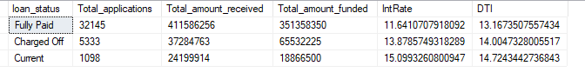

**MTD LOAN STATUS**

SELECT

loan_status,

COUNT(id) AS MTD_Total_applications,

SUM(total_payment) as MTD_Total_amount_received,

SUM(loan_amount) as MTD_Total_amount_funded,

avg(int_rate)*100.0 as MTD_IntRate,

avg(dti)*100.0 as MTD_DTI

from

bank_loan_data

WHERE MONTH(issue_date) = (SELECT MAX(MONTH(issue_date)) FROM bank_loan_data)

AND YEAR(issue_date) = (SELECT MAX(YEAR(issue_date)) FROM bank_loan_data)

group by

loan_status;

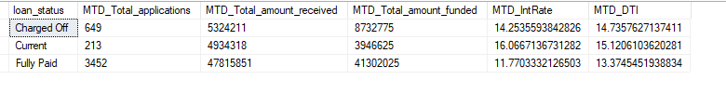

1. **BANK LOAN REPORT | OVERVIEW**

**MONTHLY TREND:**

SELECT

MONTH(issue_date) as Month_Number,

DATENAME(MONTH, issue_date) as Month_Name,

COUNT(id) as Total_applications,

SUM(total_payment) as Total_amount_received,

SUM(loan_amount as Total_amount_funded,

from

bank_loan_data

group by

MONTH(issue_date), DATENAME(MONTH, issue_date)

order by

MONTH(issue_date)

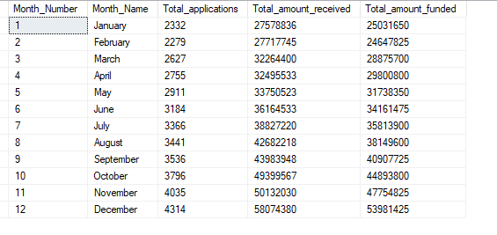

**REGIONAL ANALYSIS BY STATE**

SELECT

address_state as State,

COUNT(id) as Total_applications,

SUM(total_payment) as Total_amount_received,

SUM(loan_amount) as Total_amount_funded

from

bank_loan_data

group by

address_state

order by

SUM(loan_amount) desc

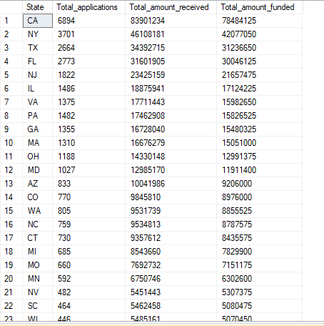

**TERM ANALYSIS**

SELECT

term as Loan_Term,

COUNT(id) as Total_applications,

SUM(total_payment) as Total_amount_received,

SUM(loan_amount) as Total_amount_funded

from

bank_loan_data

group by

term

order by

term DESC

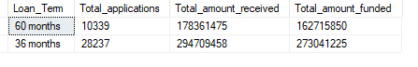

**EMPLOYEE LENGTH**

SELECT

emp_length AS Employee_Length,

COUNT(id) AS Total_Loan_Applications,

SUM(loan_amount) AS Total_Funded_Amount,

SUM(total_payment) AS Total_Amount_Received

FROM bank_loan_data

GROUP BY emp_length

ORDER BY emp_length

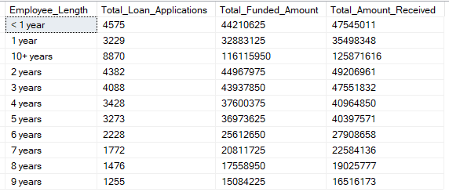

**PURPOSE**

SELECT

purpose AS PURPOSE,

COUNT(id) AS Total_Loan_Applications,

SUM(loan_amount) AS Total_Funded_Amount,

SUM(total_payment) AS Total_Amount_Received

FROM bank_loan_data

GROUP BY purpose

ORDER BY purpose

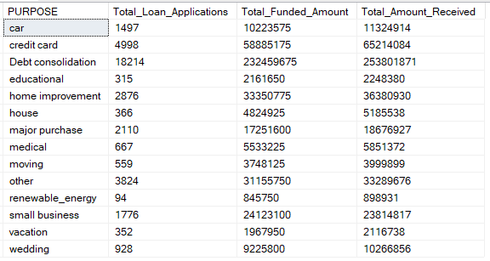

**HOME OWNERSHIP**

SELECT

home_ownership AS Home_Ownership,

COUNT(id) AS Total_Loan_Applications,

SUM(loan_amount) AS Total_Funded_Amount,

SUM(total_payment) AS Total_Amount_Received

FROM bank_loan_data

GROUP BY home_ownership

ORDER BY home_ownership

